[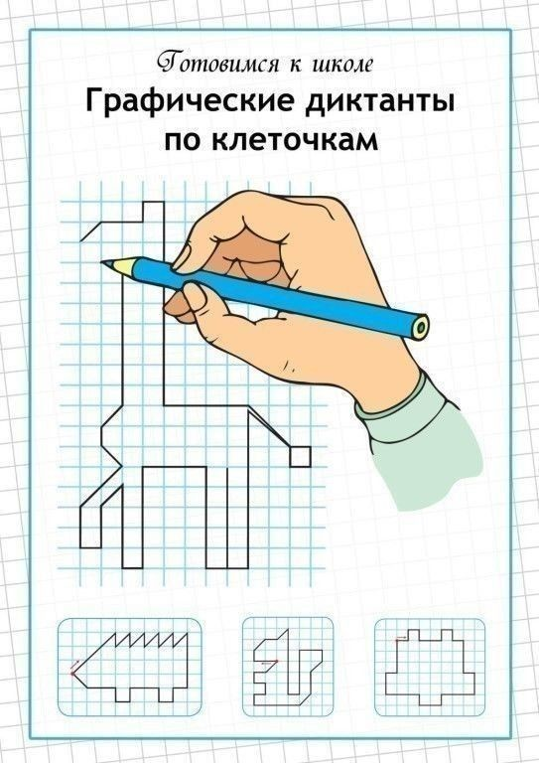](https://ok.ru/dk?cmd=PopLayerPhoto&st.layer.cmd=PopLayerPhotoOuter&st.layer.type=GROUP&st.layer.revNav=off&st.layer.limitedUi=false&st.layer.closeLayers=off&st.layer.sphotoIds=900175983028;900175983284;900175983540;900175983796;900175984052;900175984308;900175984564&st.layer.showNav=on&st.layer.photoAlbumId=53539413622964&st.layer.epm=off&st.layer.photoId=900175983028&st.layer.wasRedirect,=off&st.layer.opl=off&st.layer.navStartPhotoId=900175983028&st.layer.navStartAlbumId,=53539413622964&st.layer.sbd=off&st.cmd=bookmarks&st.typeId=7&st._aid=GroupTopicLayer_openPhotoLayer)

[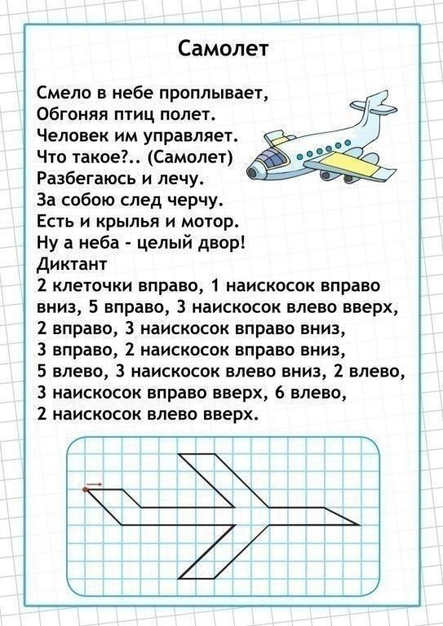](https://ok.ru/dk?cmd=PopLayerPhoto&st.layer.cmd=PopLayerPhotoOuter&st.layer.type=GROUP&st.layer.revNav=off&st.layer.limitedUi=false&st.layer.closeLayers=off&st.layer.sphotoIds=900175983028;900175983284;900175983540;900175983796;900175984052;900175984308;900175984564&st.layer.showNav=on&st.layer.photoAlbumId=53539413622964&st.layer.epm=off&st.layer.photoId=900175983284&st.layer.wasRedirect,=off&st.layer.opl=off&st.layer.navStartPhotoId=900175983284&st.layer.navStartAlbumId,=53539413622964&st.layer.sbd=off&st.cmd=bookmarks&st.typeId=7&st._aid=GroupTopicLayer_openPhotoLayer)

[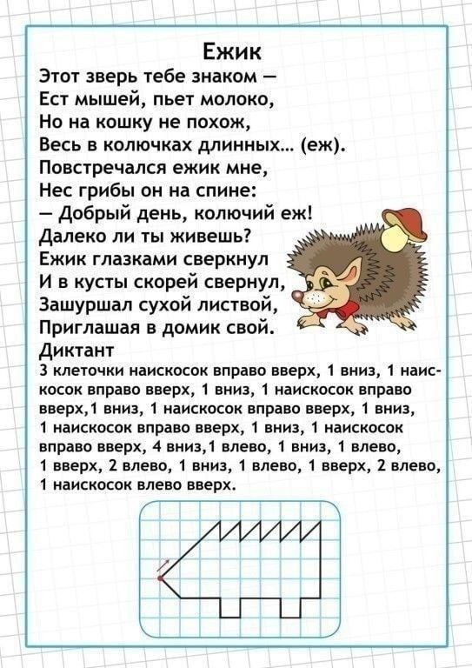](https://ok.ru/dk?cmd=PopLayerPhoto&st.layer.cmd=PopLayerPhotoOuter&st.layer.type=GROUP&st.layer.revNav=off&st.layer.limitedUi=false&st.layer.closeLayers=off&st.layer.sphotoIds=900175983028;900175983284;900175983540;900175983796;900175984052;900175984308;900175984564&st.layer.showNav=on&st.layer.photoAlbumId=53539413622964&st.layer.epm=off&st.layer.photoId=900175983540&st.layer.wasRedirect,=off&st.layer.opl=off&st.layer.navStartPhotoId=900175983540&st.layer.navStartAlbumId,=53539413622964&st.layer.sbd=off&st.cmd=bookmarks&st.typeId=7&st._aid=GroupTopicLayer_openPhotoLayer)

[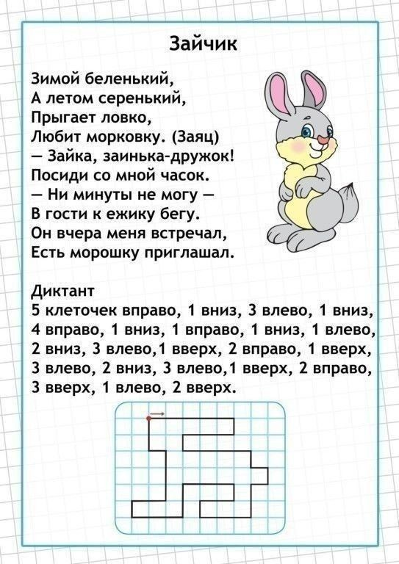](https://ok.ru/dk?cmd=PopLayerPhoto&st.layer.cmd=PopLayerPhotoOuter&st.layer.type=GROUP&st.layer.revNav=off&st.layer.limitedUi=false&st.layer.closeLayers=off&st.layer.sphotoIds=900175983028;900175983284;900175983540;900175983796;900175984052;900175984308;900175984564&st.layer.showNav=on&st.layer.photoAlbumId=53539413622964&st.layer.epm=off&st.layer.photoId=900175983796&st.layer.wasRedirect,=off&st.layer.opl=off&st.layer.navStartPhotoId=900175983796&st.layer.navStartAlbumId,=53539413622964&st.layer.sbd=off&st.cmd=bookmarks&st.typeId=7&st._aid=GroupTopicLayer_openPhotoLayer)

[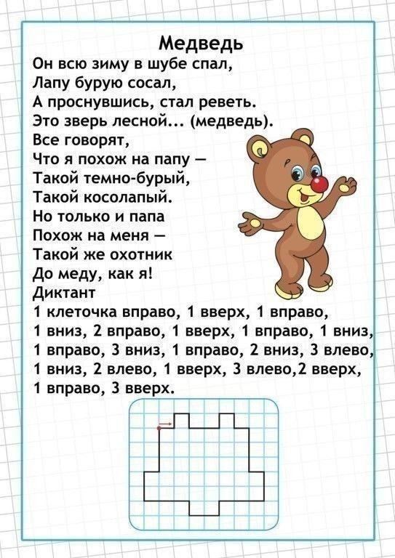](https://ok.ru/dk?cmd=PopLayerPhoto&st.layer.cmd=PopLayerPhotoOuter&st.layer.type=GROUP&st.layer.revNav=off&st.layer.limitedUi=false&st.layer.closeLayers=off&st.layer.sphotoIds=900175983028;900175983284;900175983540;900175983796;900175984052;900175984308;900175984564&st.layer.showNav=on&st.layer.photoAlbumId=53539413622964&st.layer.epm=off&st.layer.photoId=900175984052&st.layer.wasRedirect,=off&st.layer.opl=off&st.layer.navStartPhotoId=900175984052&st.layer.navStartAlbumId,=53539413622964&st.layer.sbd=off&st.cmd=bookmarks&st.typeId=7&st._aid=GroupTopicLayer_openPhotoLayer)

[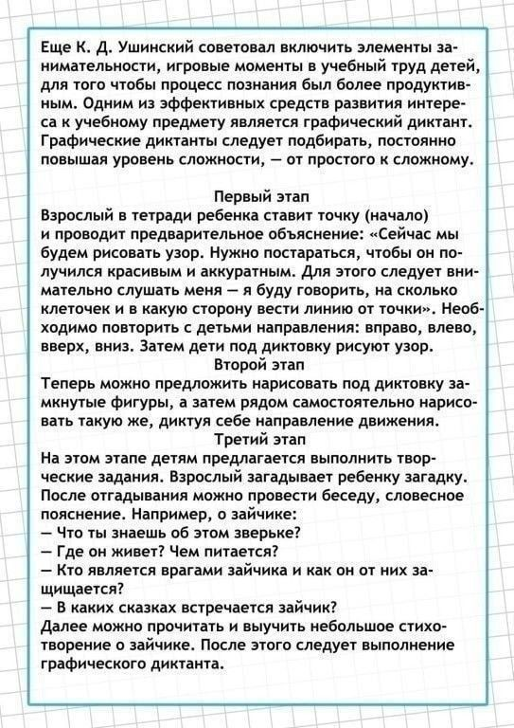](https://ok.ru/dk?cmd=PopLayerPhoto&st.layer.cmd=PopLayerPhotoOuter&st.layer.type=GROUP&st.layer.revNav=off&st.layer.limitedUi=false&st.layer.closeLayers=off&st.layer.sphotoIds=900175983028;900175983284;900175983540;900175983796;900175984052;900175984308;900175984564&st.layer.showNav=on&st.layer.photoAlbumId=53539413622964&st.layer.epm=off&st.layer.photoId=900175984308&st.layer.wasRedirect,=off&st.layer.opl=off&st.layer.navStartPhotoId=900175984308&st.layer.navStartAlbumId,=53539413622964&st.layer.sbd=off&st.cmd=bookmarks&st.typeId=7&st._aid=GroupTopicLayer_openPhotoLayer)

[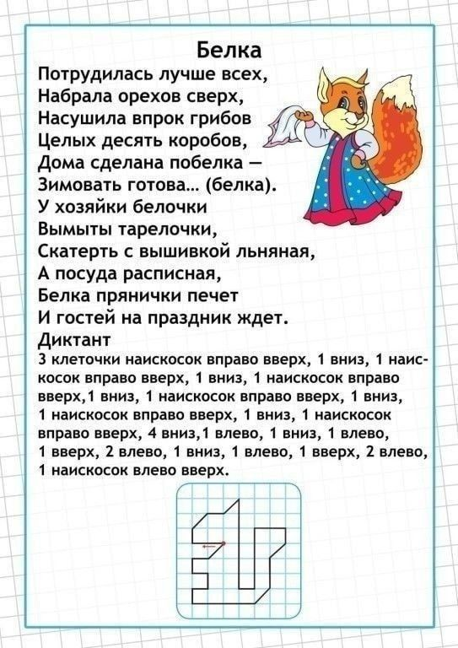](https://ok.ru/dk?cmd=PopLayerPhoto&st.layer.cmd=PopLayerPhotoOuter&st.layer.type=GROUP&st.layer.revNav=off&st.layer.limitedUi=false&st.layer.closeLayers=off&st.layer.sphotoIds=900175983028;900175983284;900175983540;900175983796;900175984052;900175984308;900175984564&st.layer.showNav=on&st.layer.photoAlbumId=53539413622964&st.layer.epm=off&st.layer.photoId=900175984564&st.layer.wasRedirect,=off&st.layer.opl=off&st.layer.navStartPhotoId=900175984564&st.layer.navStartAlbumId,=53539413622964&st.layer.sbd=off&st.cmd=bookmarks&st.typeId=7&st._aid=GroupTopicLayer_openPhotoLayer)

***РАЗВИВАЕМ ВНИМАНИЕ, ПАМЯТЬ, ЛОГИЧЕСКОЕ МЫШЛЕНИЕ***

[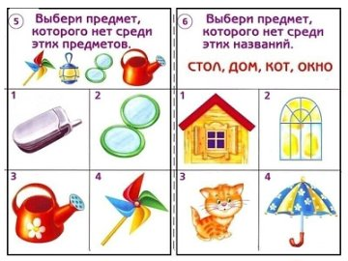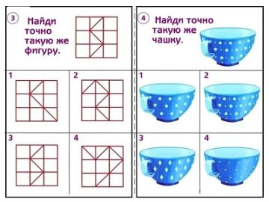](https://ok.ru/logopedvos/topic/151498069424308)

[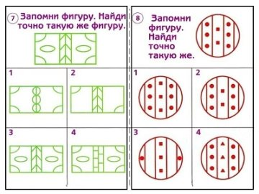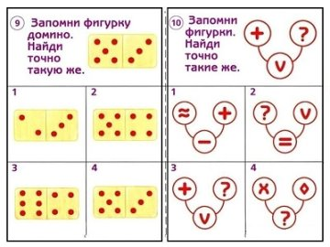](https://ok.ru/logopedvos/topic/151498069424308)

[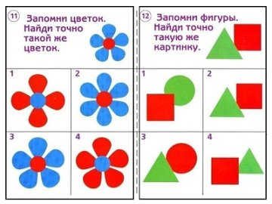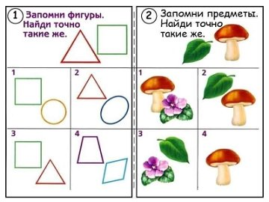](https://ok.ru/logopedvos/topic/151498069424308)

***Игры со словами***

[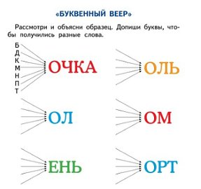](https://ok.ru/razumeykin/topic/151391569688002)

[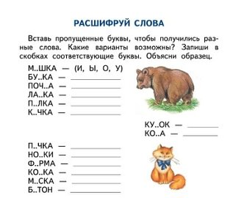](https://ok.ru/razumeykin/topic/151391569688002)

[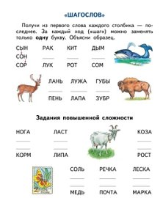](https://ok.ru/razumeykin/topic/151391569688002)

[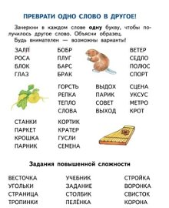](https://ok.ru/razumeykin/topic/151391569688002)

Реши примеры

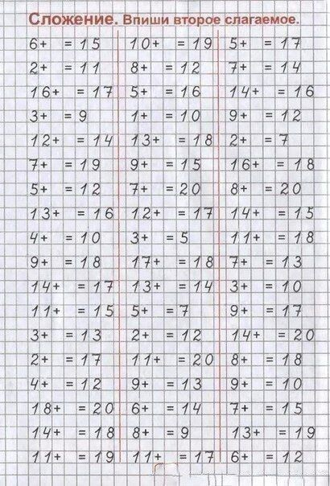 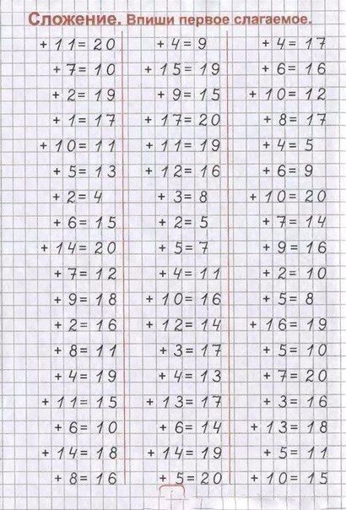

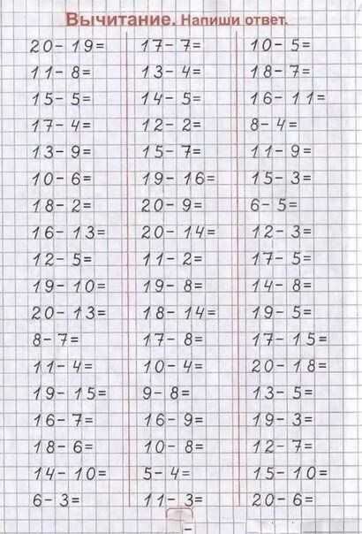 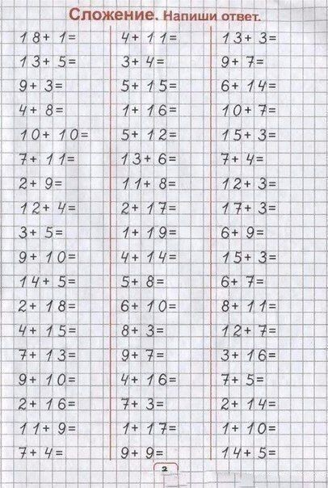

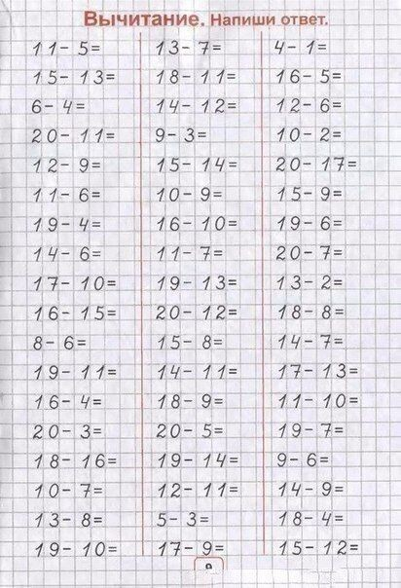 

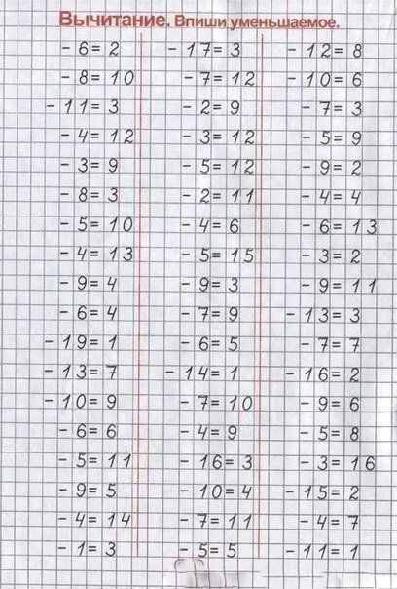 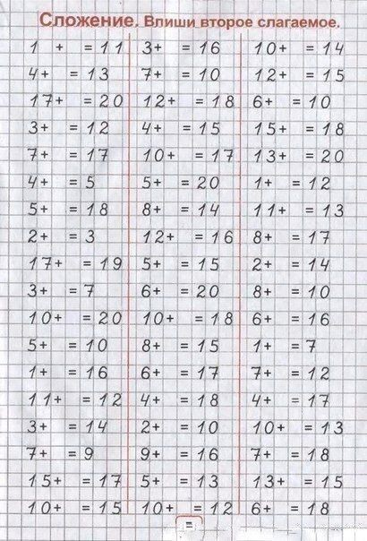



[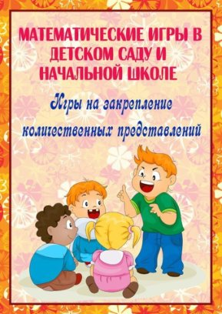](https://ok.ru/doshkolnik/topic/151385136079004) [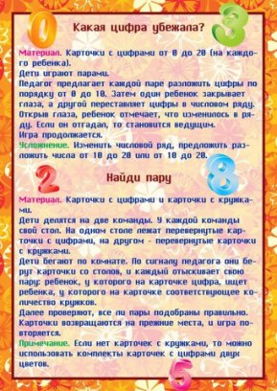](https://ok.ru/doshkolnik/topic/151385136079004)

[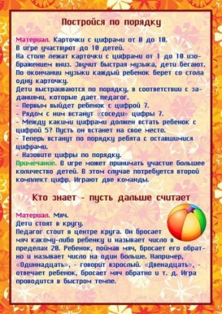](https://ok.ru/doshkolnik/topic/151385136079004) [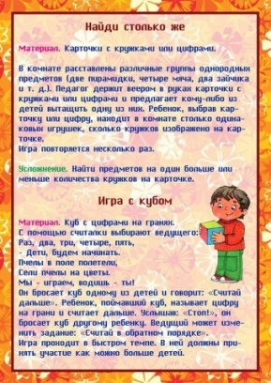](https://ok.ru/doshkolnik/topic/151385136079004)

[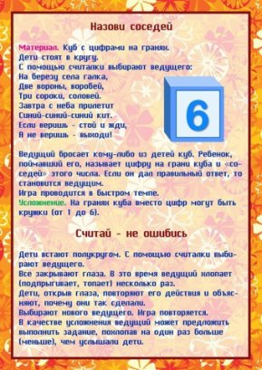](https://ok.ru/doshkolnik/topic/151385136079004) [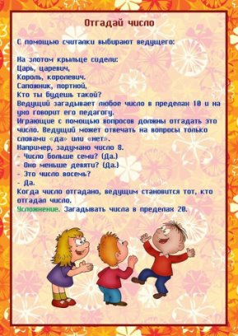](https://ok.ru/doshkolnik/topic/151385136079004)

[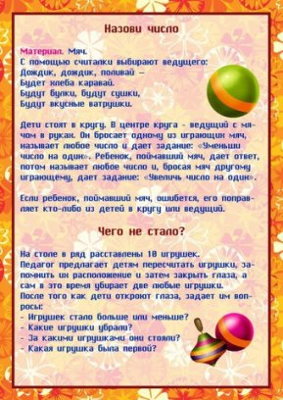](https://ok.ru/doshkolnik/topic/151385136079004) [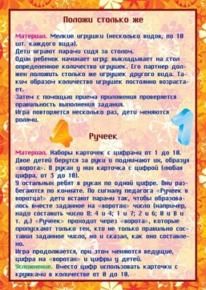](https://ok.ru/doshkolnik/topic/151385136079004)